Commands in linux

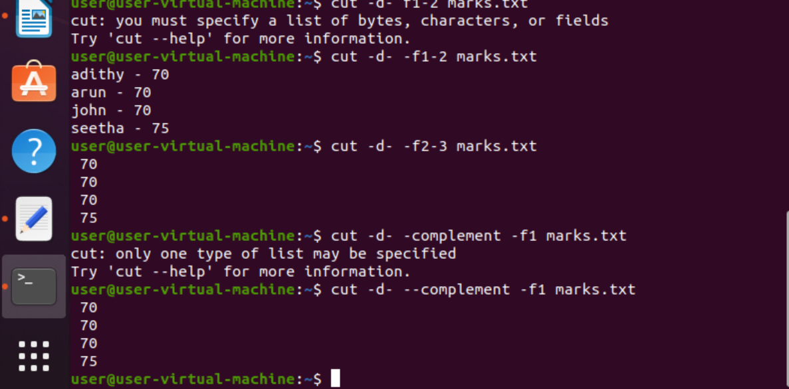
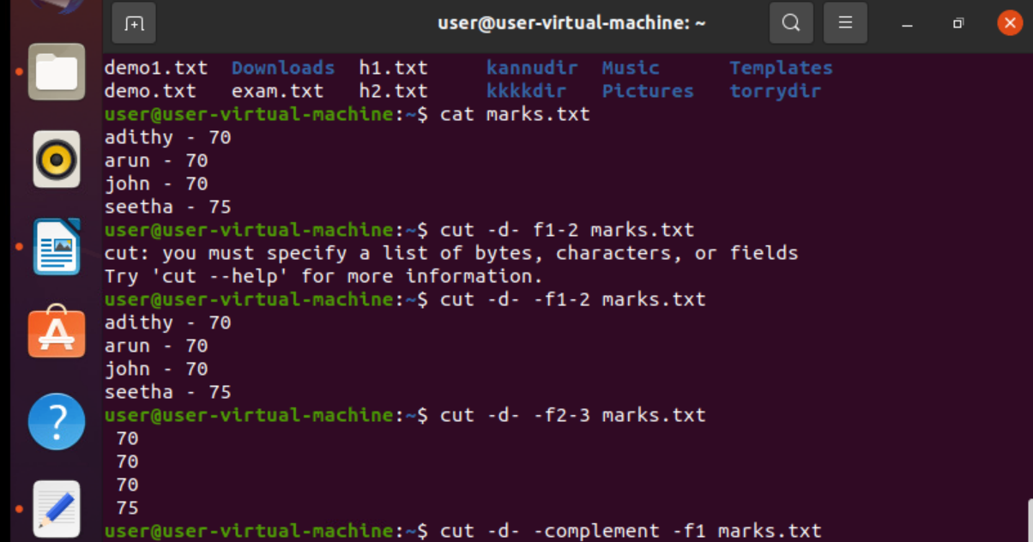
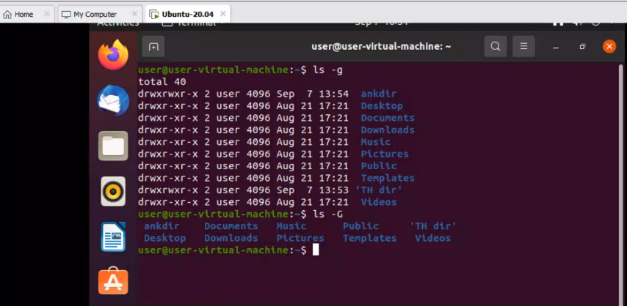
\

example solved shell script

1. create a file with names of places
sort the in natural order and redirect it to an output file
2. sort in reverse order and redirect it to an output file . print the output file
3. create a file with two fields seperated with -
field-1 name
field-2 age
print age of all the people using cut
4. create a file have words "happy"
print only the lines which starts with word "happy" use grep command
5. list all the subdirectories of within a directory.
6. Count all the words , characters and lines in a file
7. print only the lines which have digits in a given file
8. print only the lines which have digits in a given file. copy the contents into an output file by the deleting the numbers
123hi
hey345
jackandjill
merrygo10timesround
remove the numbers and print it
9. display the file with line numbers
10. display lines from two files by converting the first file lines into uppercase and second file lines into lowercase.

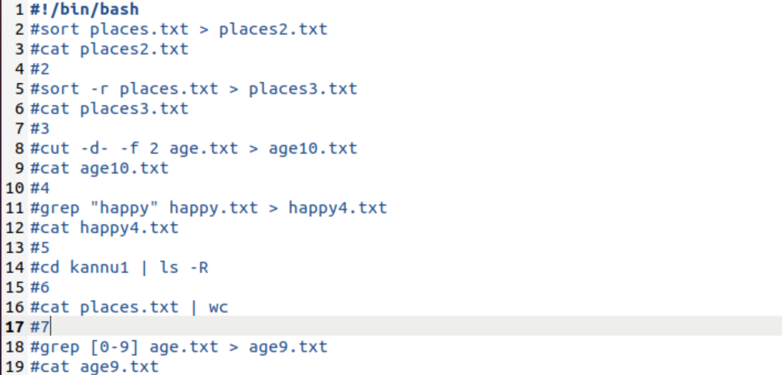
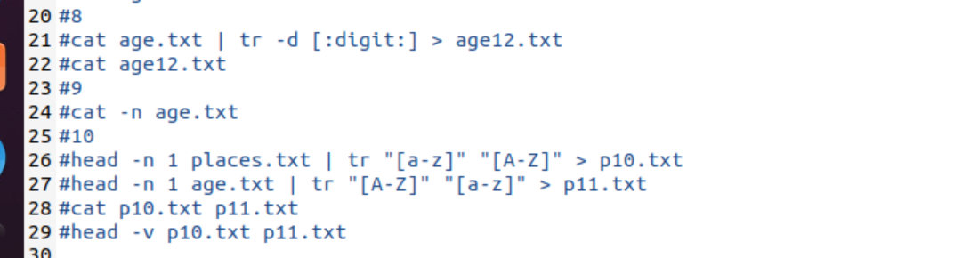
Special variables in bash sell
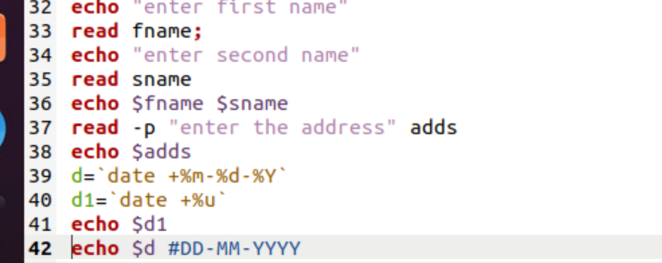

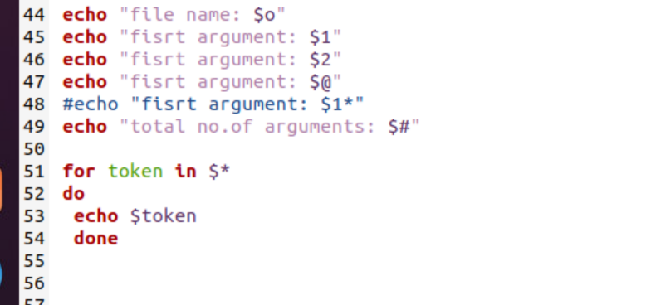

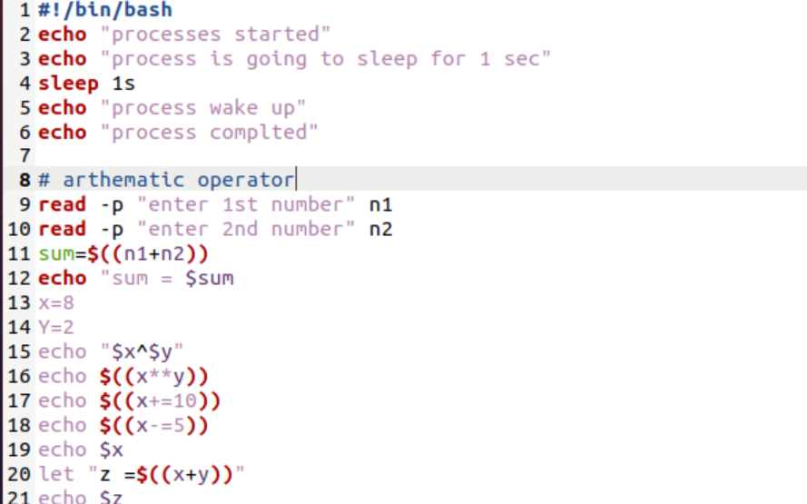

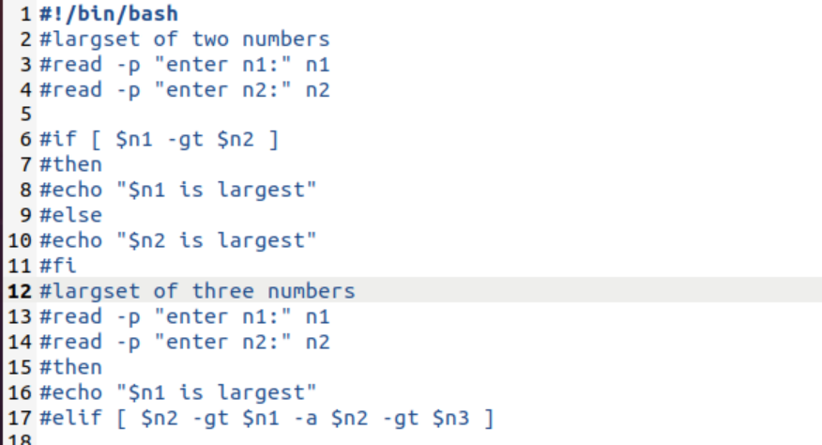

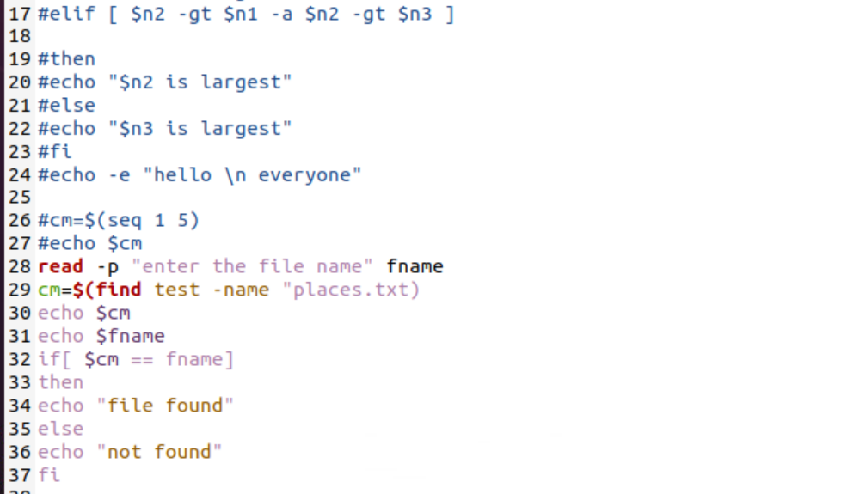

sequence

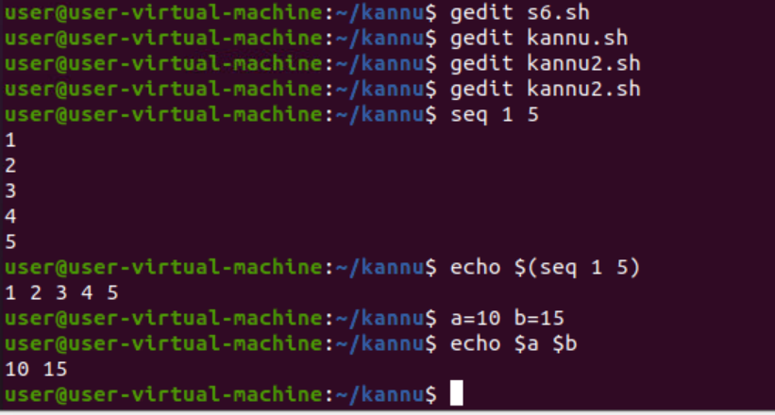

loop statement

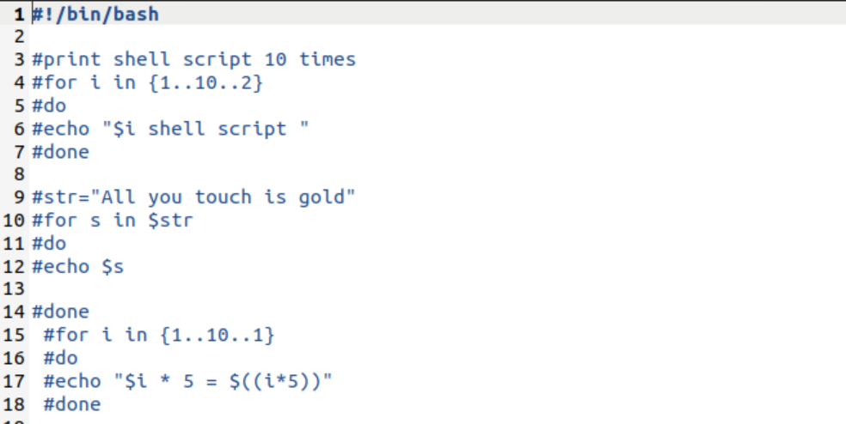

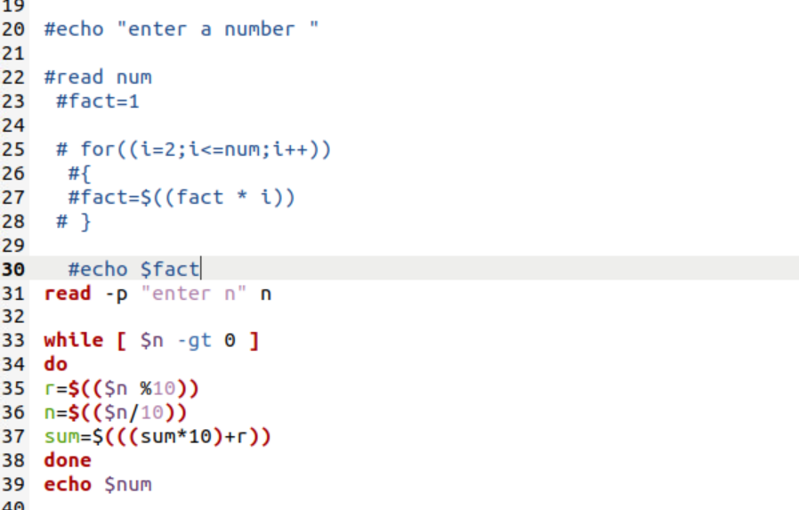

while loop

